# Cover Page:

Contents:

Cover Page: 1

Contents: 2

Abstract: 3

Acknowledgement: 4

List of Figures: 5

List of Tables: 6

List of Abbreviations: 7

Introduction: 8

Background: 8

Objectives: 9

Limitations: 10

Literature Review: 12

Methodology: 15

Introduction: 15

Dataset: 15

Software and Hardware Specifications: 16

Deep Learning Architectures: 17

Deep Learning Optimizers: 18

Training Specifications: 19

Code implementation and explanation: 20

Data Preparation and Splitting: 20

Data Augmentation and Preprocessing using Image Data Generators: 22

Utilizing Custom Callback in Model Training: 24

Results 27

Presentation of Findings 27

Analysis of Results 27

10. Chapter 5 - Discussion 28

- 5.1 Interpretation of Results 28

- 5.2 Comparison with Previous Studies 28

- 5.3 Implications of Findings 28

11. Chapter 6 - Conclusion 29

- 6.1 Summary of Findings 29

- 6.2 Contributions to the Field 29

- 6.3 Recommendations for Future Research 29

12. References 30

13. Appendices 31

# Abstract:

Recently, various state-of-the-art deep learning (DL) algorithms have been used to classify plant diseases on publicly available/author-generated datasets. In this research, a deep learning-based comparative analysis was proposed for plant disease classification. First, a comparative analysis of well-known CNN architectures was proposed. The research found a convolutional neural network (CNN) a best Second, which attempted to improve the performance of the realized model by training on various deep learning optimizers have been developed. The comparison between different CNNs was based on performance metrics such as validation accuracy/loss, F1 score, and number of required epochs All the selected DL architectures were trained on the PlantVillage dataset with 26 different diseases in 14 plant species. Keras with a TensorFlow backend was used to train the deep learning algorithm. It is concluded that the Xception architecture trained with Adam optimizer obtained the highest verification accuracy and F1-score of 99.87% and 0.9978, respectively, better than the previous methods and indicating the novelty of the work Therefore, the method proposed in this study can be applied in other agricultural applications to identify its explicit classification.

# Acknowledgement:

First and foremost, I would like to express my deepest gratitude to my advisor, Dr. Bappaditya Mandal, for his continuous support and guidance throughout my BSc project. This project would not have been possible without his direction and constant assistance.

Secondly, I would like to thank Ash leake for his technical support and for providing timely resource arrangement.

Finally, I would like to thank my family for continually believing in me. They have always encouraged me never to give up in pursuing my goals. Without their love and presence, the successes as well as the failures would have been meaningless.

# List of Figures:

Figure 1. The methodology of this research. 17

Figure 2. Some of the plant diseases from the PlantVillage dataset. 18

Figure 3. Data Splitting - Code Snippet 20

Figure 4. Data Augmentation - Code Snippet 22

Figure 5. Custom Callback - Code Snippet 25

# List of Tables:

Table 1. Hyperparameters of the deep learning optimizers 17

# List of Abbreviations:

# Introduction:

## Background:

Agriculture is considered to play an important role in sustaining human life and ensuring food security around the world. With the global population projected to reach 9 billion by 2050, there is increasing pressure to increase agricultural productivity and reduce challenges such as plant diseases. Plant diseases have economic and environmental impacts, leading to crop losses, reduced yields, and increased use of pesticides.

Traditional approaches to diagnosis and management are often relied upon, which can be time-consuming, subjective, and limited in feasibility. Modern technology combinations, especially computer vision and machine learning, are seen as promising solutions to address these challenges. By using big data and advanced algorithms, automated systems for rapid, accurate diagnosis and targeted therapy in plants can be developed.

The availability of datasets such as the Plant Village dataset has changed the landscape of plant disease research. The Plant Village dataset contains a high-quality collection of images showing a variety of plant diseases including fungi, viruses, and pathogens as well as samples of healthy plants. These labelled images serve as valuable training data for training and evaluation of machine learning models, especially convolutional neural networks (CNNs).

The use of pre-existing CNN architectures such as ResNet, VGG, and Inception is seen to provide a structured approach to modelling, allowing researchers to focus on optimizing and generalizing model performance. It also gives flexibility and improves convergence speed during training.

## Objectives:

This study aims to evaluate and compare the performance of various pre-existing convolutional neural network (CNN) architectures for accurate plant disease classification using the Plant Village dataset. The objective of the study is to aid insights in the selection of optimal models to optimize agricultural applications. To achieve this objective, the following objectives will be pursued.

First, several CNN algorithms, including ResNet, VGG, and Inception etc, will be trained on the Plant Village dataset. Standardized preprocessing techniques and hyperparameters will be used to ensure the accuracy of the models. The trained models will then be evaluated and compared based on their classification accuracy, robustness, and computational efficiency.

Second, various optimization algorithms such as Adamax, Adadelta, and RMSProp will be used to evaluate their impact on model convergence performance and trade-off analysis between convergence speed and accuracy. The results obtained by each optimizer will be analysed to understand their effectiveness in training CNN models for classifying plant diseases.

Third, model performance will be evaluated using standard metrics including accuracy, precision, recall, and F1-score. The generation and analysis of confusion matrices will provide insight into the ability of different models to correctly identify different plant diseases and will further contribute to more detailed studies of classification efficiencies.

Then, the study aims to identify and compare the best-performing CNN designs and optimization algorithms based on established evaluation metrics and criteria. This requires intensive research to understand the strengths and limitations of each model in a real-world agricultural setting.

Finally, research findings will be discussed in terms of their practical implications for agricultural stakeholders. The potential benefits of applying advanced machine learning techniques to plant disease diagnosis and management will be highlighted, as well as suggestions for new research directions such as increasing the quality of data collection, sample preparation techniques, and potential applications in precision agriculture.

## Limitations:

This research project has several limitations that define the context and the boundaries of the study. First, the reliance on plant village dataset for model training and analysis poses limitations on dataset representativeness. Although the list covers a wide range of plant diseases, it may not include all possible variations and environmental factors encountered in actual agricultural conditions. These limitations require caution when attributing outcomes are moving into broader agricultural contexts or diversity contexts.

Second, computer hardware plays an important role in the size and complexity of the experiments conducted in this study. Limited technical capacity may prevent analysis of large datasets, complex model architectures, or detailed hyperparameter tuning, which may affect the depth of analysis and optimization achieved.

Furthermore, the choice of the overall findings are specific choices related to CNN architectures, optimization algorithms, dataset preprocessing techniques, although these choices are made deliberately to maintain the accuracy of the experiment, they can hinder limit the applicability of the results to other models or data structures.

Furthermore, time constraints of the experimental timeline may limit sample replication, thorough sensitivity assessment, or long-term performance monitoring These time constraints may affect thorough sample analysis and finding alternative routes or methods.

Finally, external factors such as changes in disease prevalence, changing environmental factors, or extracurricular technological advances may affect the relevance and consumption of research findings in the long run.

# Literature Review:

Plant pathologists classify plant diseases by examining several plant sections, such as the root, kernel, stem, and leaf. In a report he presented, Ferentinos used various categorization systems for plant diseases. High accuracy disease architectures are designed by CNN models. Researchers Brahimi et al. examined 14828 photos of tomato leaves with nine distinct illnesses on them. 99.18% accuracy was achieved by the CNN model with the help of isolated sick leaf patches and a large enough dataset. Plant pests may seriously hurt crops and cost farmers a lot of money. In his study, Dawei et al. employed transfer learning to increase the precision of pest identification and showed encouraging outcomes. Singh and others. The suggested classifier outperformed transfer learning techniques (AlexNet, ResNet, VGG16, Inception V3) and other machine learning algorithms (SVM, Decision Tree, Logistic Regression, and KNN), achieving 96.46% accuracy. Utilizing a region-based CNN model, Hasan et al. estimated wheat output with an average accuracy ranging from 88% to 94%. The model was used to calculate the production yield of several wheat cultivars. Patil and Bodhe collected sugarcane leaf shape features in order to identify plant diseases. Using threshold segmentation and triangle segmentation, they were able to identify the leaf and lesioning region with 98.6% accuracy. In a research study titled "Using deep learning for image-based potato tuber disease detection," Oppenheim et al. employed a CNN model to classify potato diseases using computer vision. Oppenheim et al. divided tubers into five groups using the CNN technique. In a study report published in 2016, Barbedo, Jiang, and colleagues determined the image processing research needs for autonomously diagnosing plant illnesses. Jiang et al. [17] presented the real-time apple leaf disease classification method based on rainbow concatenation and the VGGInception model. Using the Apple Leaf Dataset, the suggested method demonstrated a 97.14% test accuracy. The suggested method fared better than other well-known pre-trained models. In Atole et al.'s research publication [18], rice plants were classified into three classes with an accuracy of 91.23% utilizing a pretrained AlexNet deep network. In a research study, A. P. Singh demonstrated how to use an artificial bee colony for feature selection in order to identify the ideal feature set needed for a support vector machine classifier to identify diseases in photos of grape plants. The accuracy of the suggested algorithm was 92.14%. For the purpose of classifying plant species, Zhu et al. used Inception V2 with batch normalization and found that this method produced results that were more accurate than Faster RCNN. Zhang put out a categorization system that he called varied region-based CNN, which is able to extract features and encode context-aware representation. Image segmentation and image classification are the two steps in the two-step method for plant leaf disease identification that Nanehkaran et al. proposed. It was suggested to segment images using hue, saturation, and intensity. In order to attain greater accuracy, the segmented images were classed using the CNN model. Using the deep learning model R-CNN, W. Shaohua and S. Goudos (2020) exhibited faster and more accurate object detection. Rani et al. introduced D-Leaf, a deep learning-based technique for identifying plant species. Machine learning approaches were employed to handle the task of picture classification, while pre-trained models were utilized for feature extraction. The accuracy of the D-leaf model using the ANN classifier was 94.88%. Zhao et al. presented an image classification strategy for improving the Support Vector Machine (SVM) model's hyper-parameters using an enhanced artificial bee colony nature-inspired optimization algorithm. Particle swarm optimization (PSO-SVM) and Genetic algorithm (GA)—SVM techniques were examined for a comparative analysis. With an accuracy of 98.28%, the suggested technique outperformed alternative comparable methods for the classification of hyperspectral pictures. Algorithms inspired by nature employ practical optimization techniques. Genetic optimization, three-parent genetic optimization, parallel three-parent genetic algorithm, artificial bee colony, particle swarm optimization, cuckoo search, ant colony optimization, big bang big crunch, parallel big bang big crunch, and other popular nature-inspired optimization techniques are examples. Numerous fields have successfully implemented deep learning techniques. Gao et al. proposed IDONET, an intrusion detection system that uses improved mask R-CNN for power grid surveillance. The suggested model outperformed the other cutting-edge object identification models when it came to small item detection after being trained for it. A method to classify photos of rice blast, brown mark disease, and bacterial blight (a total of 1500 images) with 94% accuracy was proposed by Bhattacharya et al. This work presents a deep learning-based approach whose hyper-parameters can be adjusted through the use of optimization algorithms inspired by nature.

# Methodology:

## Introduction:

Convolutional Neural Networks (CNNs) have been widely utilized for image classification tasks, prompting this research to investigate the performance of several novel CNN architectures for classifying plant diseases. All 5 DL architectures considered for this study were recently published in large research articles on plant disease classification, as depicted in Figure 1.

The overall methodology employed in this study was to train the 5 DL architectures on the Plant Village dataset using 3 different optimizers for each. The convergence of the 5 CNN architectures to the final training/validation values was observed to update the hyperparameters. Subsequently, the CNN models were compared in terms of training and validation accuracy/loss, as well as F1-score. This comparison led to the utilization of DL optimization algorithms to further enhance the performance of their CNN architectures, resulting in the highest F1 score in their specific category.

## Dataset:

All DL models were trained on the publicly available Plant Village dataset, which contains 54,306 images with 38 different healthy/diseased leaves associated with their 14 plant species (some of the plant diseases are shown in Figure 3), image size Converted to 224 × 3 and normalized by dividing the pixels values ​​by 255 to match the initial values ​​of the models To avoid overfitting, 70%, 20% and 10% data sets were allocated of the training, validation and test data sets, respectively.

## Software and Hardware Specifications:

The software environment for this research work is developed using Python 3.11.4 in compatible operating systems such as Linux, Windows, or macOS. The primary integrated development environment (IDE) used for coding and testing is Google Colab and Kaggle. These environments provide a robust platform for the development and successful implementation of machine learning models.

This research relies on several core libraries and resources for data binding, deep learning model development, and visualization. System libraries such as os, time, shutil, and pathlib facilitate file management, time-sensitive operations, and access management in the operating system. For data processing and transformation, the OpenCV library (cv2) is used for graphical representation, while numpy and pandas are used for numerical calculations and data analysis tasks, respectively.

Deep learning functions are implemented using TensorFlow version 2.9.1 and Keras libraries. TensorFlow provides the backbone for building and training deep learning models, while Keras provides a high-level API for building simple neural networks The Keras.preprocessing.image module supports image data processing and enhancement through the ImageDataGenerator class. Various layers (e.g., Conv2D, MaxPooling2D, Dense) and optimizers (e.g., Adamax, RMSprop, Adadelta) from Keras are used for model architecture and optimization.

The software stack also includes tools for model evaluation and visualization. The sklearn library is used for confusion matrices, classification reports, and model evaluation metrics. In addition, data visualization is facilitated by the use of seaborn and matplotlib.pyplot to create informative plot graphs.

All experiments were performed on a graphical processing unit (2 x NVIDIA T4) with specifications: 16GB GDDR6 memory, 2560 CUDA cores and 320 Tensor cores, 1590 MHz core clock, and 320 GB/sec memory bandwidth.

## Deep Learning Architectures:

Following the creation of the AlexNet architecture, a groundbreaking era of cutting-edge CNN architectures was initiated for several image categorization applications. Thus, we examined well-liked and effective CNN models including VGG-16, ResNet-50, MobileNet, EfficientNetB3, and Xception in this article.

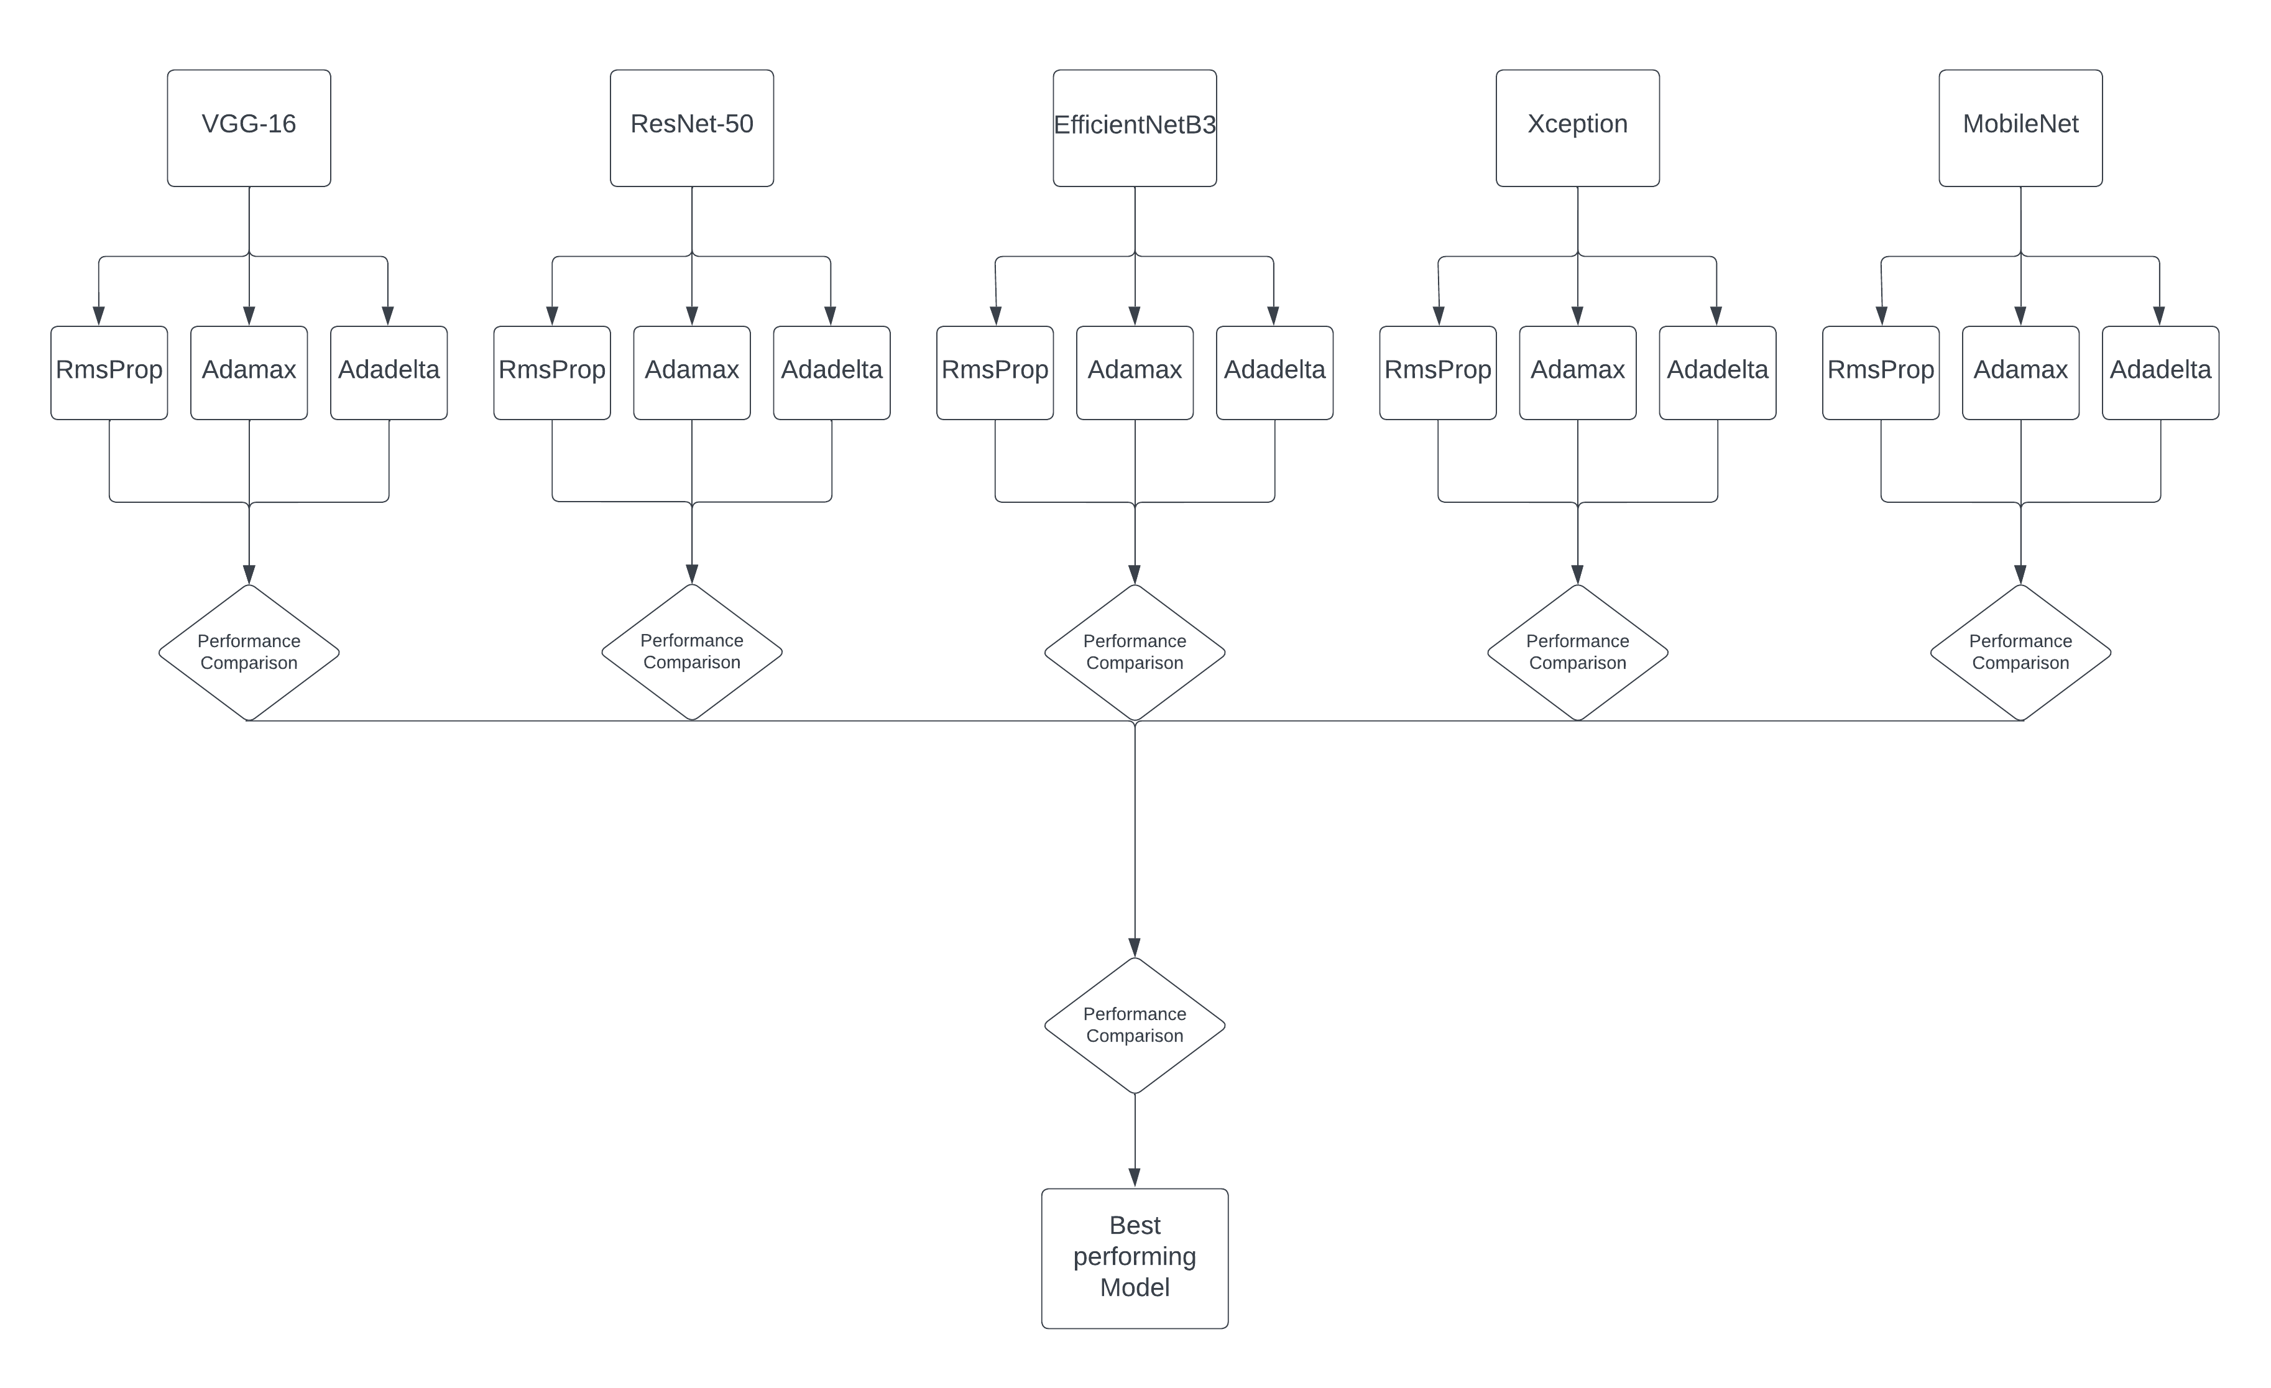

Figure 1. The methodology of this research.

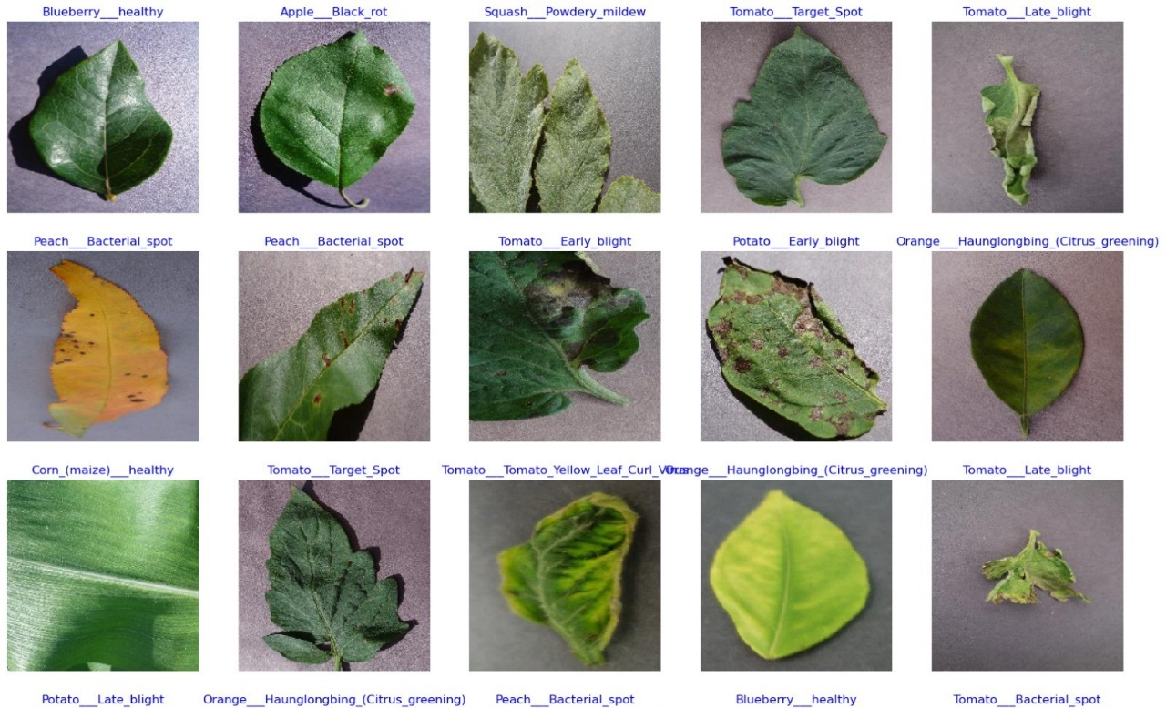

Figure 2. Some of the plant diseases from the PlantVillage dataset.

## Deep Learning Optimizers:

All the DL models were trained using 3 state-of-the-art deep learning optimizers. Some characteristics of these optimizers are provided as follows:

1. RMSProp: Learning rates were adjusted individually for each parameter during training. This was achieved by maintaining a moving average of squared gradients for each parameter, thus normalizing updates. This adaptability enabled faster convergence and stability in training deep neural networks.
2. Adadelta: Adadelta, an extension of the Adagrad algorithm, further addressed its tendency to decrease the learning rate monotonically. This was accomplished by using a sliding window of the squared gradients to compute adaptive learning rates, allowing for more stable and efficient training.
3. RMSProp: Adaptive learning rates for each parameter were computed by maintaining a moving average of the squared gradients. This normalization of learning rates allowed for more stable and efficient training of deep neural networks.

## Training Specifications:

All DL models were trained from scratch on the PlantVillage dataset. The hyperparameters were tuned using the random search method. The internal covariate shift problem was observed in neural networks due to variations in the input data distribution caused by changes in the number of parameters in the previous layers. This problem was addressed using Batch Normalization, a method known for its effectiveness in handling the high learning rate. The ReLU activation function was employed to train all DL models, chosen for its computational efficiency and its ability to mitigate the vanishing gradient problem. The specifications of all DL optimizers are summarized in Table 1.

Table 1. Hyperparameters of the deep learning optimizers

|  |  |
| --- | --- |
| Optimizers | Specifications |
| RMSProp |  |
| Adadelta |  |
| Adamax |  |

## Code implementation and explanation:

### Data Preparation and Splitting:

Figure 3. Data Splitting - Code Snippet

1. define_paths(data_dir)

* This function takes the directory path where the dataset is stored as input.
* It iterates through each fold (subdirectory) in the dataset directory and collects file paths and their corresponding labels.
* File paths and labels are stored in separate lists (file paths and labels).
* Returns the list of file paths and corresponding labels.

2. define_df (files, classes)

* This function takes two lists as input: files (list of file paths) and classes (list of corresponding labels).
* It creates two pandas Series objects: Fseries for file paths and Lseries for labels.
* Then it concatenates these two Series along the columns axis to form a DataFrame.
* Returns the DataFrame containing file paths and labels.

3. split_data (data_dir)

* This function orchestrates the process of splitting the dataset into training, validation, and testing sets.
* It utilizes the previously defined functions define_paths () and define_df () to obtain the DataFrame containing file paths and labels.
* Firstly, it creates the training DataFrame by splitting the entire dataset into 80% for training and 20% for validation and testing combined.
* Then, it splits the remaining data (validation and testing combined) equally into validation and testing DataFrames, each containing 10% of the original dataset.
* Stratified splitting is applied to maintain the distribution of classes across splits.
* Returns three DataFrames: train_df for training, valid_df for validation, and test_df for testing.

### Data Augmentation and Preprocessing using Image Data Generators:

Figure 4. Data Augmentation - Code Snippet

Function: create_gens (train_df, valid_df, test_df, batch_size)

This function prepares data generators for training, validation, and testing data. It utilizes the Keras ImageDataGenerator to perform data augmentation and preprocessing.

1. Defining Model Parameters:

* img_size: The desired size for input images after resizing.
* channels: The number of color channels in the images (e.g., 3 for RGB).
* color: The colour mode for images ('RGB' or 'grayscale').
* img_shape: The shape of input images (height, width, channels).

1. Customizing Test Batch Size:

* It calculates a suitable batch size for the test data based on the length of the test DataFrame to ensure efficient memory usage.
* The batch size is dynamically adjusted to fit the test data while keeping it within a reasonable range.

1. Defining Data Augmentation Function:

* A custom function scalar(img) is defined to perform minimal preprocessing on images. In this case, it simply returns the input image unchanged.

1. Creating ImageDataGenerators:

* Two ImageDataGenerator objects (tr_gen for training and ts_gen for validation and testing) are instantiated.
* tr_gen is configured with data augmentation parameters such as horizontal flipping to augment training data.
* ts_gen is used for validation and testing and does not perform data augmentation.

1. Flowing Data from DataFrames:

* Training, validation, and testing data are fed into the corresponding ImageDataGenerator objects using flow_from_dataframe () method.
* DataFrames (train_df, valid_df, test_df) are passed along with relevant parameters such as file paths, labels, target size, colour mode, class mode, shuffle, and batch size.
* For training and validation, shuffle is set to True to shuffle the data for each epoch. For testing, shuffle is set to False to maintain the order of data.

1. Returning Data Generators:

* Returns three data generators: train_gen, valid_gen, and test_gen containing augmented and pre-processed data ready to be fed into the deep learning model.

### Utilizing Custom Callback in Model Training:

The custom callback class, named as MyCallback, constitutes a pivotal component within the research, offering a suite of customizable functionalities aimed at optimizing the training process. It facilitates real-time monitoring of crucial training metrics, such as accuracy and validation loss, both at the culmination of each epoch and batch iteration. Through this continuous evaluation, insights were gained into the model's performance, enabling informed decisions regarding learning rate adjustments and overall model optimization strategies. Moreover, MyCallback affords a level of flexibility that allows for user interaction during training, enabling intervention, parameter adjustments, or decision making based on real-time observations or experimental requirements.

Figure 5. Custom Callback - Code Snippet

1. Setting up Callback Parameters:

* The parameters such as patience, stop_patience, threshold, factor, ask_epoch, and batches are predefined to configure the behaviour of the custom callback during training.

2. Instantiating the Callback:

* The custom callback MyCallback is instantiated with the defined parameters and passed to the callbacks list.
* This list holds the callback objects that will be executed during model training.

3. Training the Model with Callbacks:

* During model training, the callbacks list is passed to the fit () method of the model.
* This ensures that the defined callback functions are executed at specific points during training.

# Results

## Introduction to Results:

The study's findings are discussed in this part, with an emphasis on comparing the effectiveness of many convolutional neural network (CNN) architectures trained with various optimizers for the goal of predicting leaf disease using the Plant Village dataset. The study set out to identify which architecture and optimizer combination produced the greatest overall performance and maximum accuracy in classifying leaf diseases through extensive experimentation and analysis.   
The investigation's main focuses were covered by the results that were given. First, per-epoch data analysis revealed information about each model's training progress, including adjustments to learning rate, accuracy, and loss. Through this study, it was possible to see how well each model learnt from and adjusted to the training set over the course of several epochs.

Each model's performance in training, validating, and testing was also evaluated, and measures like accuracy and loss were looked at to see how well the models generalized to new data. Important insights into the robustness and generalization capacities of the trained models were obtained by comparing performance across several datasets.   
In addition, a thorough examination of the classification reports produced by each model was given, examining parameters like F1-score, precision, and recall for distinct classes. This research allowed for the discovery of each model's strengths and weaknesses by providing a detailed understanding of how well it classified particular leaf diseases.

The study sought to determine which CNN architecture(s) and optimizer(s) provided the most promising outcomes for leaf disease prediction by thoroughly comparing the models. The study of plant pathology gained important insights by clarifying the advantages and disadvantages of each strategy, which enhanced knowledge of the use of deep learning methods in agricultural research.   
The findings were thoroughly analysed, their ramifications were explored, and possible directions for further research in this area were indicated in the sections that followed.

## Training Progress:

Table 2.Training Time Comparison

|  |  |  |  |
| --- | --- | --- | --- |
| Architecture | Training time with Adamax | Training time with Adadelta | Training time with RMSProp |
| EfficenetNetB3 | 111 | 101 | 151 |
| MobileNet | 50 | 54 | 53 |
| ResNet50 | 116 | 140 | 108 |
| VGG-16 | 119 | 126 | 118 |
| Xception | 154 | 210 | 236 |

The dynamics of the training process can be better understood by examining the training times for each architecture using a variety of optimizers. EfficenetNetB3 showed significant differences in training times among the architectures based on the optimizer that was used. Notably, Adadelta yielded the least training time of 101 minutes, whereas RMSProp produced the longest training time of 151 minutes. This discrepancy implies that each optimizer has different optimization efficiencies and convergence rates, which affect the total training time needed for model convergence.

By comparison, MobileNet showed impressive uniformity in training durations for all optimizers, with the lowest variation found to be between 50 and 54 minutes. This consistency points to a strong optimization process in which the intrinsic properties of the design support steady and effective model convergence. ResNet50 also showed a similar pattern, albeit Adadelta had the longest training period at 140 minutes, as opposed to 116 minutes for Adamax and 108 minutes for RMSProp. This disparity highlights the impact of the optimizer on training effectiveness, with some optimization techniques showing better convergence performance for topologies.

In addition, VGG-16 demonstrated comparatively consistent training times for all optimizers, spanning from 118 to 126 minutes. This consistency points to a well-balanced optimization process involving many optimization techniques, wherein the optimization of parameters and the complexity of the architecture converge effectively. On the other hand, out of all the architectures, Xception showed the most differences in training times; RMSProp produced the longest training period, at 236 minutes, followed by Adadelta (210 minutes) and Adamax (154 minutes). This discrepancy highlights how sensitive some structures are to optimization techniques; more complex models necessitate longer optimization procedures to reach convergence.

All things considered, the training time study clarifies the complex relationship among architecture complexity, optimizer choice, and training effectiveness. A thorough analysis of training times for different optimizers and designs provides important information about the parameters affecting computing resource needs and model convergence. These results advance our knowledge of the deep learning optimization process and guide future attempts to design models with the goal of improving training effectiveness and convergence rates.

# 10. Chapter 5 - Discussion

# - 5.1 Interpretation of Results

# - 5.2 Comparison with Previous Studies

# - 5.3 Implications of Findings

# 11. Chapter 6 - Conclusion

# - 6.1 Summary of Findings

# - 6.2 Contributions to the Field

# - 6.3 Recommendations for Future Research

# 12. References

Ahmed, S.U., Shuja, J. and Tahir, M.A. (2023) ‘Leaf classification on Flavia Dataset: A detailed review’, *Sustainable Computing: Informatics and Systems*, 40, p. 100907. doi:10.1016/j.suscom.2023.100907.

(Ahmed et al., 2023)

# 13. Appendices